Details on how the class participation will be graded.
30% of total grade | Participation in in-class discussions of papers  Bring a digital copy of the paper on a tablet/laptop (preferred) or a print-out

- This is a participation grade and participation in all discussions is required. And everyone should present a similar number of times per quarter.
- Each of the 8 modules are worth 5 points (40 total points). You earn 5 points if you participate in the small-group discussions on Zoom and annotate the Google Presentation with your group. If you miss the class, you earn 0 points*.
- A second portion of your participation grade comes from presenting your figures to the class. Based on the class size & number of students, everyone should present 3 times. You will get 3 points each time, for a maximum of 9 points.
  - Make sure that you do not monopolize the presentations. If you have presented, you should make sure that your discussion partners present the next weeks.
  - I will post the names of students who I logged as presentations in the class slack (#4-paper-discussion channel). Please let me know if I missed you.
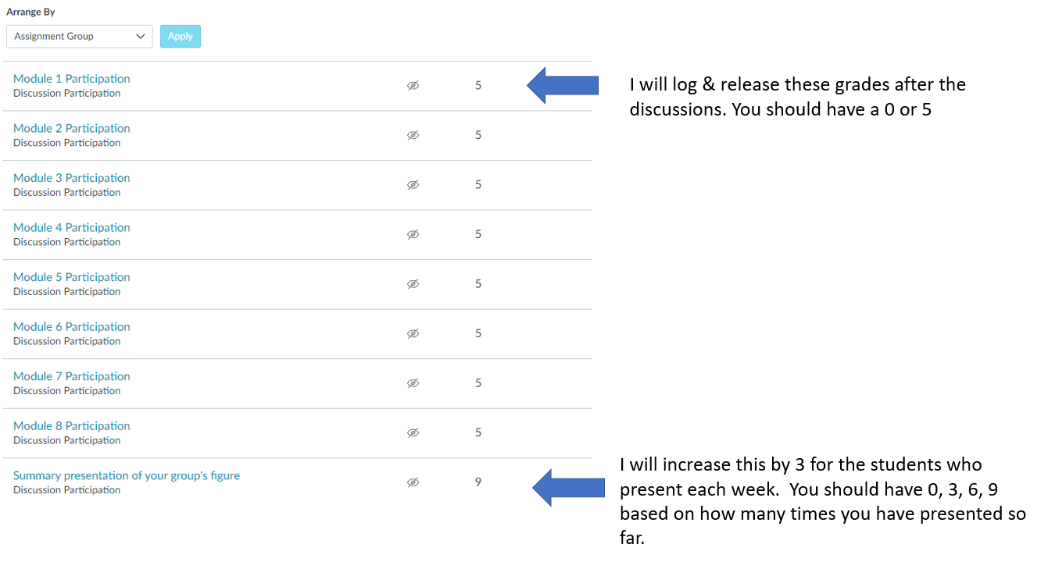
Make-up assignment
- You are allowed to make-up one paper discussion if you do not attend in-person. If you miss 2 or more discussions, then you will lose points for those discussions
- As a make-up assignment, you can write a summary of 2 Figures from the paper. Within 1 week of the missed discussion, ask in the #4-paper-discussions-channel which figures are the focus of a make-up assignment. (Do not email or direct message Prof. Lowe-Power. Posting in the channel allows her to answer the question once for all students).

